Consumer’s Guide to

Carpet Cleaning

Provided as an educational service by Mark Pritchard

Specialist in Carpet and Upholstery Cleaning

- How to avoid carpet cleaning rip-off's!
- 5 costly misconceptions about carpet cleaning
- A guide to slime, grime and livestock that’s seeping, creeping and galloping through your carpet
- Which method cleans best?
- Mistakes to avoid when choosing a carpet cleaner
- The importance of value and price
- Do you want a clean, healthy carpet?
- 100% no-risk guarantee

Dear Home owner,

Choosing a carpet cleaner isn’t easy

Why? Because you’re bombarded with misleading advertising, confusing claims and simply bad information.

From super-low prices and high-pressure sales - to unqualified technicians and near worthless methods – how do you ever find a qualified, competent, professional carpet cleaner?

You start by reading this Consumer’s Guide. In this fact-filled booklet, you’ll discover how to avoid four carpet cleaning rip-offs, mistakes to avoid when choosing a carpet cleaner, and four steps to a fresh, clean, healthy carpet.

We wrote this guide to help you better understand carpet cleaning. Now, with this information, you can make an informed, intelligent decision.

And if you have any questions about carpet or upholstery cleaning, you’re invited to call us. We’ve dedicated our business to educating consumers.
We’ll be happy to help you in every way.


Mark Pritchard…is the owner of Executive Carpet Care and is a certified technician by the Institute of Inspection Cleaning and Restoration Certification (IICRC) and a member of the NCCA (National Carpet Cleaning Association).

I have dedicated this business to helping home owners get the highest return from their carpet and upholstery investment. I welcome your inquiries and will gladly answer your questions over the telephone.

How to AVOID carpet cleaning rip-offs

UNBELIEVABLY LOW PRICE
To some degree, all of us are attracted by low price because we want to work within a budget. But some carpet cleaners use price as the bait for their false and misleading advertising. They offer a cheap price per room and then, once they are in your home, they pressure you into buying ‘add-ons.’ It’s as if you were buying a car and found that the dealer was charging you extra for the tyres and steering wheel. Carpet cleaning is not as cheap as some unethical carpet cleaners would like you to believe.

BAIT AND SWITCH
Dual process carpet cleaning describes the process of shampooing or heavy preconditioning, followed with hot water extraction cleaning. Unfortunately, unethical carpet cleaners often use dual process as a bait-and-switch technique.
Here’s how it’s done: First, they ‘bait’ you with a basic cleaning (single process) at an unbelievably low price. Then, when you call, they try to ‘switch’ you to more expensive dual-process cleaning. If you don’t fall for their switch and choose their basic service, you’ll likely receive poor workmanship using little or no chemical and they will not guarantee their work.

5 costly misconceptions
about carpet cleaning…
one
Should I wait as long as possible before having my carpet cleaned

No. Dirt is an abrasive, like sandpaper. Every time you step on your carpet, you grind dirt into the carpet fibres. This cuts your carpet. Just as if you had used a knife. This cutting causes your carpet to wear out faster. A dirty carpet will not last as long as a clean carpet. While vacuuming helps, by itself, it’s simply not enough. The longer you wait to have your carpet cleaned, the more damage you do to your carpet and the faster it wears out.

two
The only reason to clean my carpet is to make it look clean

No. As you probably know, outdoor air contains pollens, fungus, bacteria, air pollution, cigarette smoke, car exhaust – and hundreds of other chemicals. When you come into your home, you carry those pollens, bacteria and chemicals in your hair and on your skin, clothing and shoes. Not surprisingly, all those chemicals and toxins end up in your carpet.
If you have allergies, asthma, emphysema, or other breathing problems – one major source of your problem could be the pollens, fungus, smoke and chemicals in your carpet.

three
One method of carpet cleaning is as good as another

No. The dry cleaning methods which are dry foam, dry chemicals and dry compound do not rinse your carpet in any way. Instead, they may leave a dirty residue. You might say they clean your carpet only halfway. The most effective cleaning method is hot water extraction.

Hot water extraction means a hot water cleaning solution, under high pressure, is forced into your carpet and then sucked out of your carpet. Shaw Industries, the world’s largest carpet manufacturer, recommends hot water extraction as the primary method of cleaning carpets, along with an IICRC certified technician.

four
Having the right equipment is all a company needs to clean my carpets properly

Not true. Many companies own hot-water cleaners but very few companies teach their employees how to use them properly. This is why it’s important that you choose your carpet cleaner carefully. The best cleaners are those that have been certified by the Institute of Inspection, Cleaning and Restoration Certification, known as the IICRC. Before you choose a carpet cleaner, ask to see written proof of the company’s IICRC certification and also the certification.

five
The company that offers the lowest price is the company you should hire

No. I’ve seen so many problems arise from lowest-bid companies that I suggest you NEVER hire the company that quotes the cheapest price. The two most common problems are:

1 The price may not be for the services you want performed. The company may be equipped to remove only the dirt from your carpet, but you want bacteria, fungus, pollens, dust mites and tobacco residues removed as well.

2 The price you may see advertised might not be the price you pay. Many homeowners have learned that the low price they saw advertised lasted only until the carpet cleaner got into their home. Then they were pressured into paying a lot more for a variety of add-ons. (Some carpet cleaners even break the law by using illegal bait and switch tactics).

A GUIDE to the SLIME, GRIME and
LIVESTOCK thats SLEEPING,
CREEPING and GALLOPING through your CARPET.

Asphalt, Bacteria, Car exhaust, Chemicals, Dirt, Dust, Earth, Food particles, Fungus, Germs, Gravel, Grease, Grime, Grit, Hair, Industrial waste, Lint, Mites, Pet stains, Pollens, Pollutants, Rock, Sand, Smoke, Soil, Soot, Tar, Tobacco smoke, Urine and Vomit.

Plus, don’t forget living creatures, such as Dust Mites, Fleas and the Critters that live, hide and breed in your carpet.

WHICH METHOD CLEANS BEST?

Dry foam: The carpet cleaner applies shampoo to your carpet, allows it to dry, and then without rinsing sucks the dried shampoo into a vacuum. Can you imagine applying shampoo to your hair, allowing it to dry and then removing the shampoo from your head with a vacuum? This method leaves dirty residue in your carpet, which is one reason dry foam is not too effective.

Absorbent pad (bonnet buffing): This method is similar to dry foam except that the company sets a large cotton bonnet on your carpet and with a floor polishing buffer machine on top ‘buffs’ the carpet. The rotating motion causes the bonnet to absorb dirt from your carpet. This method is also called bonnet buffing. Bonnet cleaning is like trying to use a large cotton towel to mop or rub the dirt out of carpets. It’s not very effective.

Dry, absorbent powder: The dry-compound is the driest of all methods. It spreads a moist, absorbent powder through the carpet. It is allowed to dry and then sucked into a vacuum. This method leaves dry sponge particles at the base of the carpet yarn. And because the carpet is not rinsed, this method is not very effective.

Hot water extraction: This is a fancy way of saying that a hot water cleaning solution under high pressure is forced into your carpet and then sucked out again. In a recent Technical Bulletin, Shaw Industries, the world’s largest carpet manufacturer ‘recommends the hot water extraction system, which research indicates provides the best capability for cleaning’. You can choose from two different types: Truck-mount extraction, which is done with a large machine mounted in a truck or van. Or portable extraction, which is done with a smaller unit.

On which type to choose, Shaw’s Technical Bulletin states: “Cleaning can be done from a truck mounted unit outside the facility with only the hose and wand brought inside, or where a truck mounted unit cannot reach, by a portable, self contained system brought into the facility”.

8 MISTAKES TO AVOID WHEN CHOOSING A CARPET CLEANER

Choosing a carpet cleaner based on equipment alone
No question, your carpet cleaner needs first-rate equipment.
But he also needs something else. He needs employees who are skilled at operating that equipment. Many companies own hot-water extractors, but very few companies teach their employees how to use them properly. The best way to know that the carpet cleaner’s employees have been properly taught is to make sure the cleaner has been certified by the IICRC. Before you choose a carpet cleaner, ask to see written proof of the companies and technicians IICRC certification.

Choosing a carpet cleaner based on low price
Low price could be a problem in three ways (1) Low price can be the bait that attracts your phone call. Once the cleaner gets into your home he pressures you into a much more expensive job. (2) Low price can be for single-process cleaning. Rarely does the consumer know what this means and, when told, asks for dual-purpose cleaning instead, which costs much more. (3) Low price means the carpet cleaner has cheap equipment which will not effectively clean your carpet.

Choosing a carpet cleaner based on a single telephone call
Instead, invite the person to your home and ask for a specific written quotation. Then you’ll know exactly what the carpet cleaner recommends – and you won’t be the victim of high pressure tactics when the technician steps into your living room.

Choosing a carpet cleaner who doesn’t offer a Full Money-Back Guarantee
In my view, every carpet cleaning company should be fully accountable for its work. If you are not pleased with the job in every way, you should not have to pay for it. Period. Not all carpet cleaners offer a guarantee. Or, if they do, the guarantee may be limited. Ask the carpet cleaner if he offers a money-back guarantee and then make sure the carpet cleaner includes his guarantee in the quotation.

Choosing a carpet cleaner without getting comments from his other clients
Any carpet cleaner can say anything about his past jobs. And sadly, some of what he says may not be true. Make sure you ask for references or read comments from current customers so you can depend on the carpet cleaner and his work.

Choosing a carpet cleaner who is not certified by the IICRC
If your carpet cleaner is not a close friend, you may not know whether he has the knowledge or experience to clean your carpet well. If you want to be sure you’re hiring a competent professional, make sure he is IICRC certified. The carpet cleaner must earn that certification through study, experience and successful completion of formal written examinations. If effect, cleaners who are certified by the IICRC have earned a college degree in carpet cleaning.

Choosing a carpet cleaner who is not a member of the National Carpet Cleaners Association (NCCA)
NCCA is the largest trade association of carpet cleaners in the UK. So the IICRC will show they are trained, but with the NCCA they most keep to a number of rules:

1) Honest, ethical business practices, 2) staying current on the latest methods for carpet and upholstery care, cleaning and restoration, and 3) Have current insurance.
You’re making a wise decision when you have your carpets cleaned by a member of the NCCA.

THE IMPORTANCE OF VALUE AND PRICE

When you select a carpet cleaner, you’ll choose from a wide variety of cleaning methods and prices. Shaw Industries, the world’s largest carpet manufacturer, recommends hot water extraction.

Not surprisingly, having your carpet thoroughly cleaned costs more than renting a shampooer from your local hire firm.

If you bought the cheapest carpeting then renting a small shampooer might be all you need. No question, it will get out some of the dirt but the key word here is ‘some’. It will not get out many of the pollens, chemicals, bacteria and dust mite residues.

On the other hand – if you want your carpet to look good and give you years of dependable service – then you need to take extra care of it. This means you need to have it cleaned by a skilled, qualified technician at least every six months to one year, depending on the amount of soiling and foot traffic it receives. And you need to have it cleaned thoroughly and disinfected, as only a hot water extractor can do.

We use van mounted cleaning technology up to 20 times more powerful than any portable machine leaving your carpets much cleaner, healthier and dramatically reduces drying times.

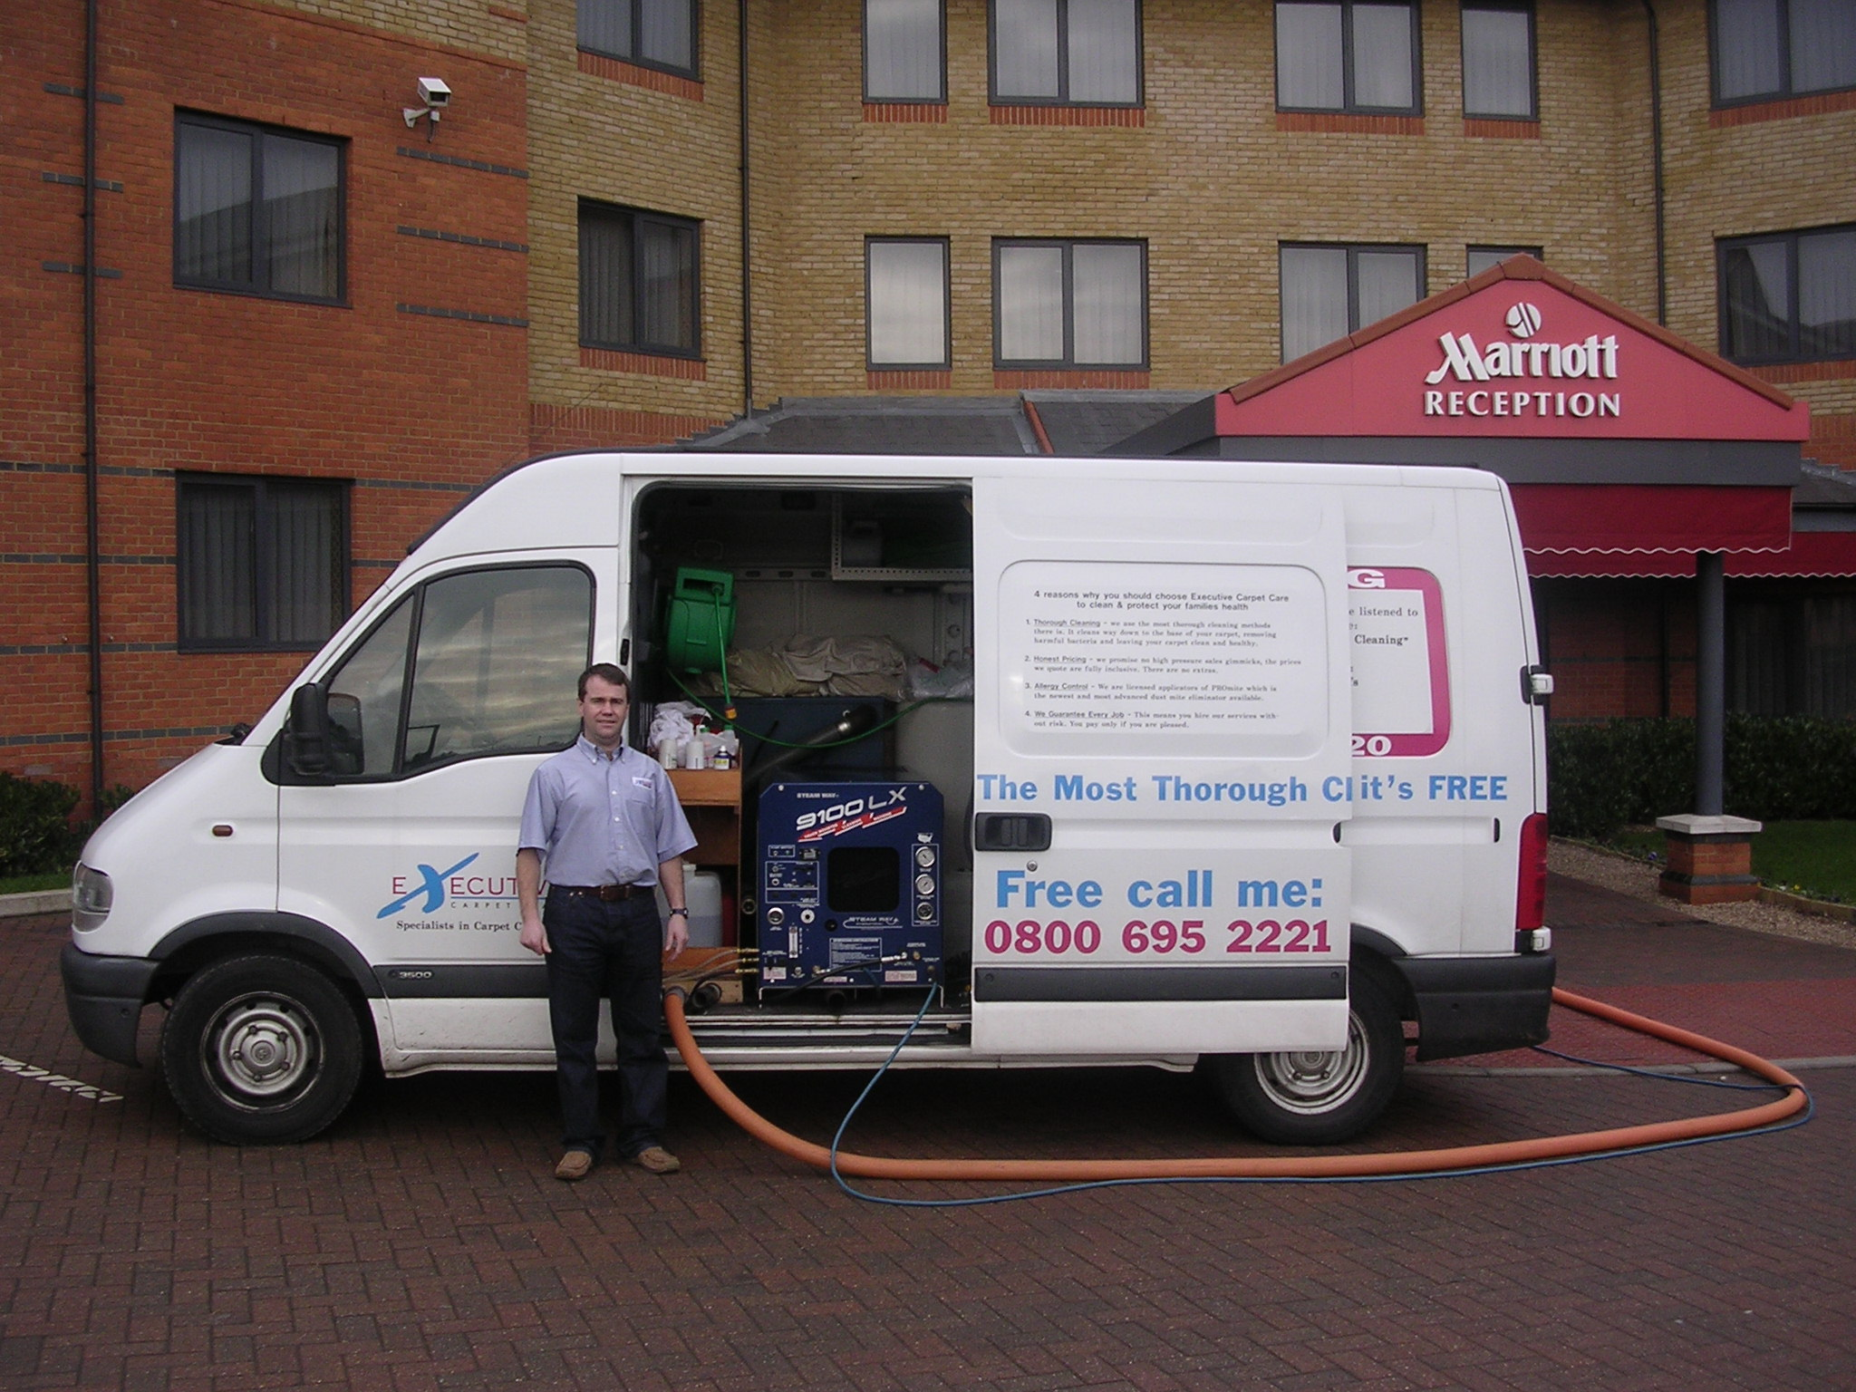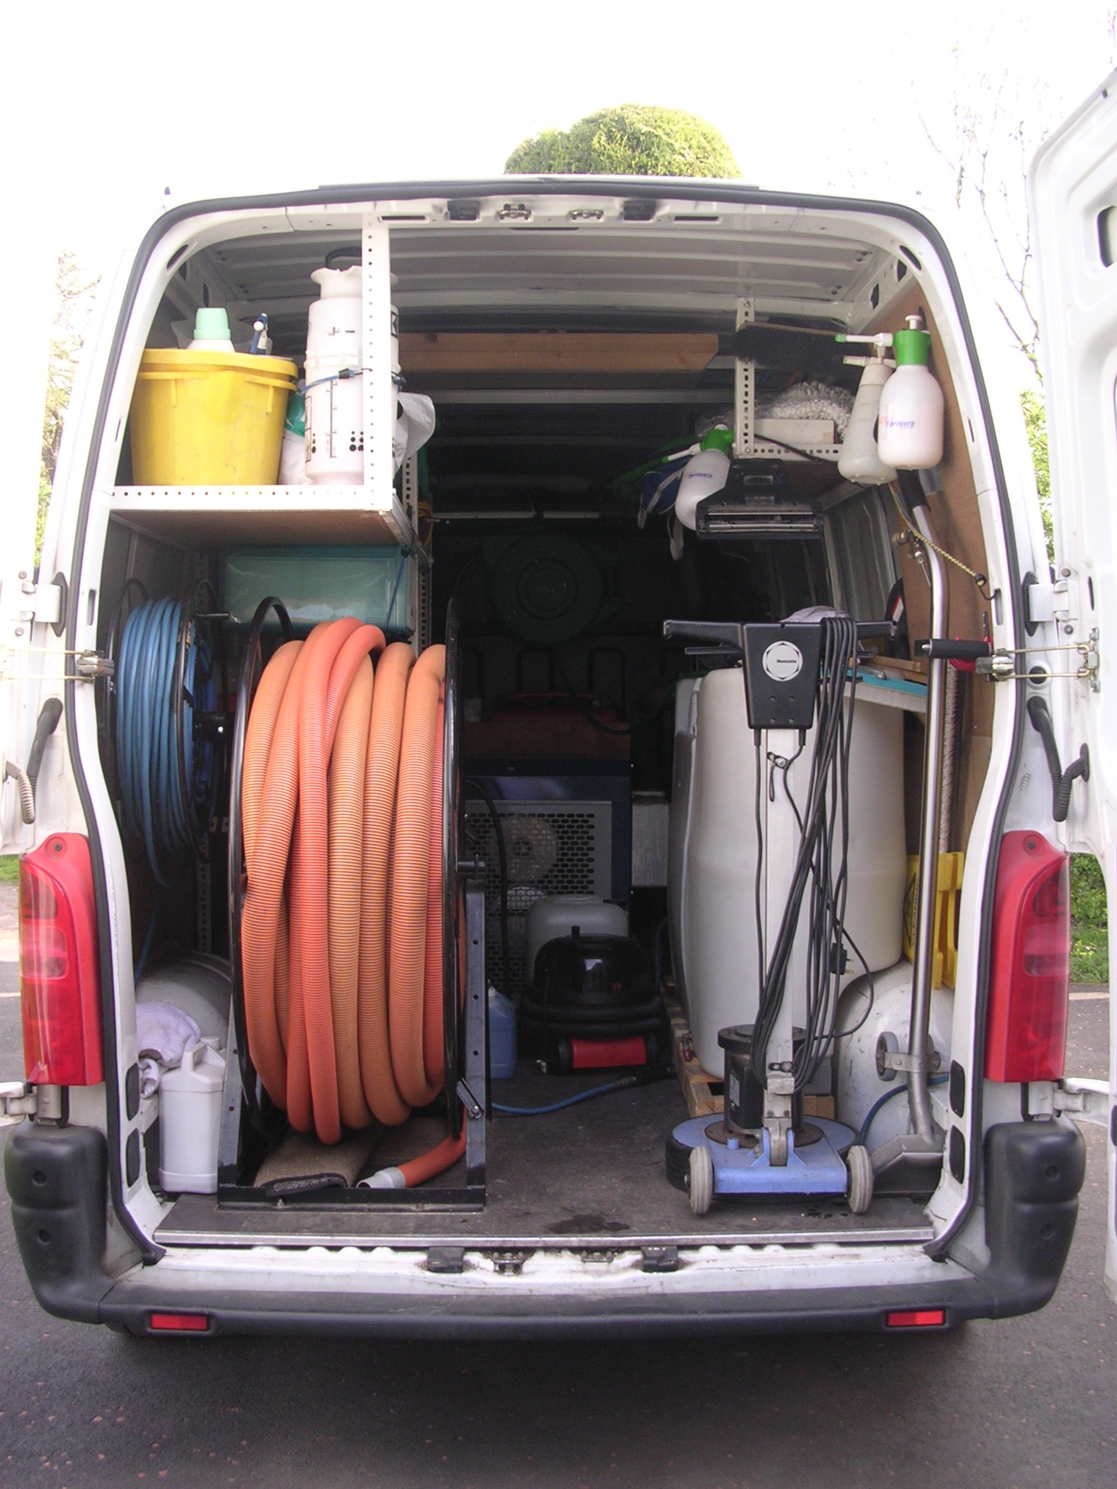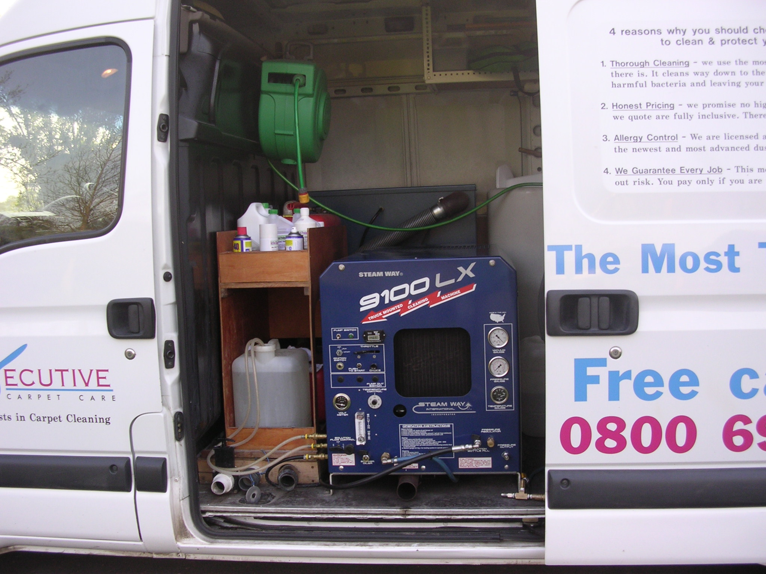

Which is more important to you: a clean carpet – or a clean and healthy carpet? Yes, I assure you there is a big difference.
Each carpet cleaning method has advantages and disadvantages. Some methods will get out only the dirt. Other methods will get out dirt and grease. Still others will get out virtually everything. And, to be sure, some are more expensive than others.

If all you want is a cheap, rinse-the-dirt-off-the-top cleaning – which I respectfully ask that you call another company.
But if you want to protect your health – if you want to protect your investment in carpeting – if you want to protect your family from the countless bacteria, fungus, pollens and dust mites that reside in your carpet, then you’re invited to call me.
The hot water unit we use is the most effective portable cleaning system available today. Likewise, it’s one of the most expensive portables units on the market. But we bought this unit for a good reason: More and more families want the good-health benefits that come from having a fresh, clean carpet.

So if you want a thoroughly clean carpet – if you’re willing to invest in your family’s good health – you’re invited to call us. You’ll receive a written estimate, at no cost or obligation

100% No-risk GUARANTEE
We want you to be super pleased – in fact, absolutely delighted – with every carpet and upholstery job we do. So every job comes with our iron-clad, risk free guarantee. What does this mean? Simply this: if you aren’t pleased, you pay nothing.

Many companies don’t guarantee their work – but we feel nothing is more important than your complete and total satisfaction. If you ever have any questions or concerns about our work, please call us right away.

THANKS AGAIN! …for reviewing our new CONSUMER’S GUIDE TO CARPET CLEANING, I hope you found this information helpful. If you have any questions or comments – or if you’d like us to give you an exact written quotation to clean your carpet or upholstery – please call us 0800 695 2221

We’ve dedicated our business to consumer education and service.
We’ll be pleased to help you in every way. We look forward to hearing from you.

